Initial Project Planning Report

|  |  |
| --- | --- |
| Date | 25-01-2024 |
| Team ID | 739927 |
| Project Name | Smart Lender-Flight Delay Prediction |
| Maximum Marks | 4 Marks |

# Product Backlog, Sprint Schedule, and Estimation

Use the below template to create a product backlog and sprint schedule

|  |  |  |  |  |  |  |  |
| --- | --- | --- | --- | --- | --- | --- | --- |
| **Sprint** | **Functional**  **Requirement (Epic)** | **User Story**  **Number** | **User Story / Task** | **Priority** | **Team**  **Members** | **Sprint Start Date** | **Sprint End Date (Planned)** |
| Sprint-1 | Data Collection  and Preprocessing | SL-3 | Understanding &loading  data | Low | Venkata sai | 2024/03/15 | 2024/03/22 |
| Sprint-1 | Data Collection and Preprocessing | SL-4 | Data cleaning | High | Venkata sai | 2024/03/15 | 2024/03/22 |
| Sprint-1 | Data Collection  and Preprocessing | SL-5 | EDA | Medium | Venkata sai | 2024/03/15 | 2024/03/22 |
| Sprint-4 | Project Report | SL-20 | Report | Medium | Venkata sai | 2024/03/15 | 2024/04/12 |
| Sprint-2 | Model Development | SL-8 | Training the model | Medium | Venkata sai | 2024/03/22 | 2024/03/29 |
| Sprint-2 | Model  Development | SL-9 | Evaluating the model | Medium | Venkata sai | 2024/03/22 | 2024/03/29 |
| Sprint-2 | Model tuning and testing | SL-13 | Model tuning | High | Venkata sai | 2024/03/22 | 2024/03/29 |
| Sprint-2 | Model tuning and testing | SL-14 | Model testing | Medium | Manoj | 2024/03/22 | 2024/03/29 |

|  |  |  |  |  |  |  |  |
| --- | --- | --- | --- | --- | --- | --- | --- |
| **Sprint** | **Functional**  **Requirement (Epic)** | **User Story**  **Number** | **User Story / Task** | **Priority** | **Team**  **Members** | **Sprint Start Date** | **Sprint End Date (Planned)** |
| Sprint-3 | Web integration  and Deployment | SL-16 | Building HTML  templates | Low | Venkata sai | 2024/03/29 | 2024/04/05 |
| Sprint-3 | Web integration and Deployment | SL-17 | Local deployment | Medium | Vyshnavi | 2024/03/29 | 2024/04/05 |

# Screenshot:

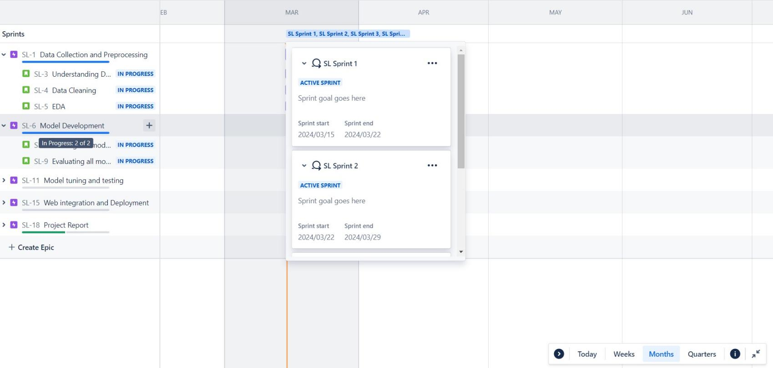

Projects/SmanLender

Allsprints



Evaluatingallmodels

Trainingthemodelwithmultiple





|@Board



-I•Addview

'/,Code



Addshortmt





Selectingthebestmodel

Modeltuning



IVlodeltesting



BuildingtheHTMLtemplates

withJSandCSS

SL-16

•+ Epic• Sprint•









GeoueBYNone• Insight 

